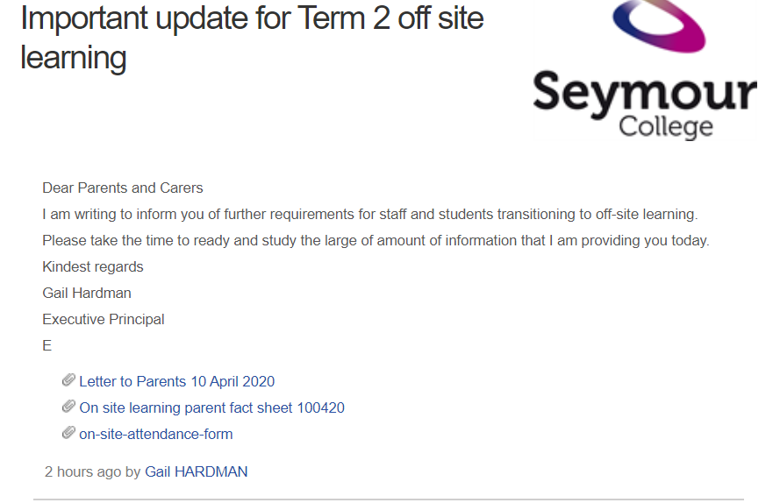
Click on the link
Click the link and it will download. Click on the download and you will see:
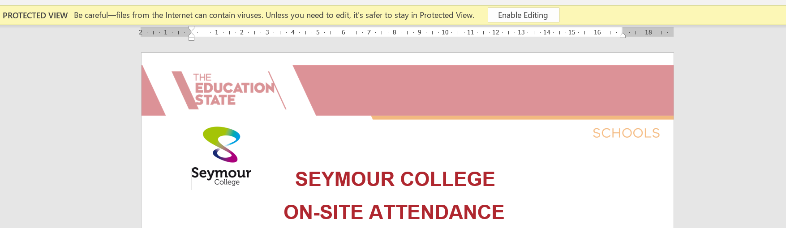
Click on Enable Editing

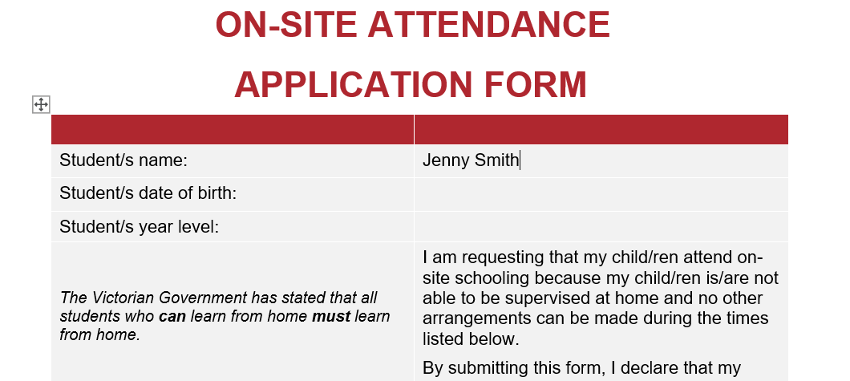
Start typing

Your e signature/typed signature is acceptable. Then email this to seymour.co@education.vic.gov.au

To email:
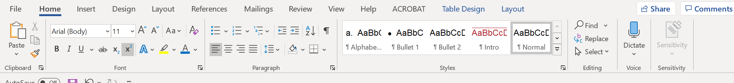

Press File

Press Share, then Email, then Send as an attachment

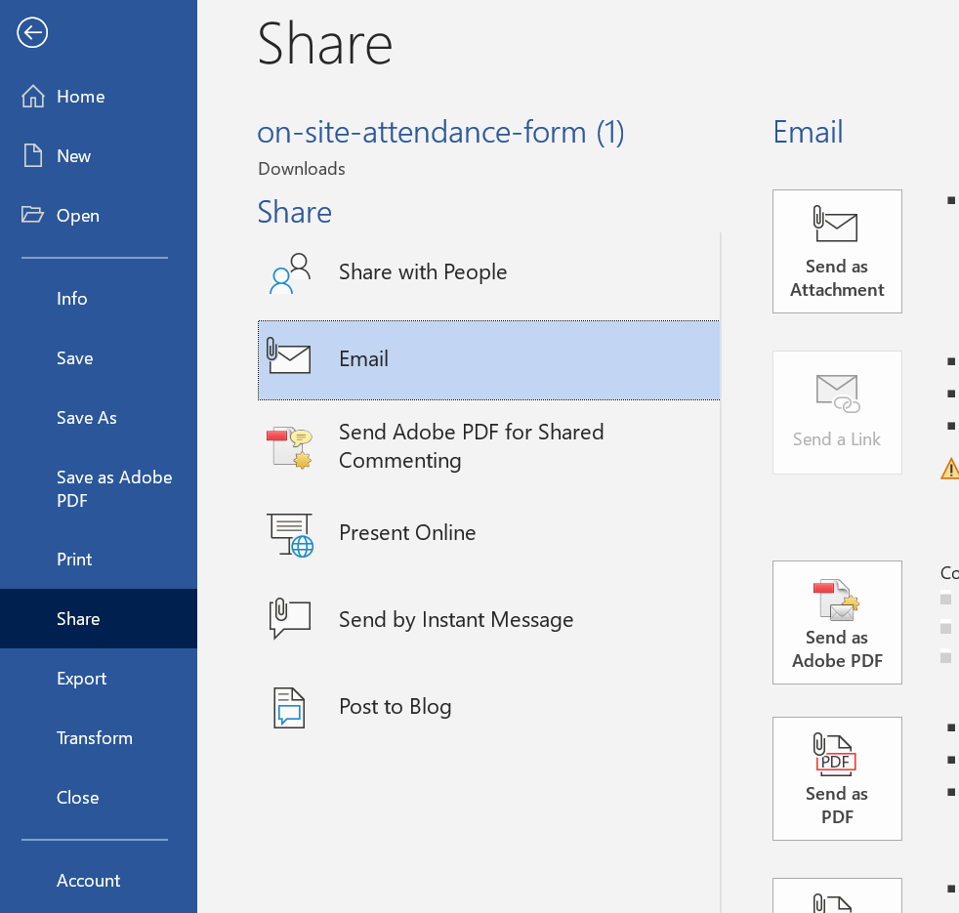
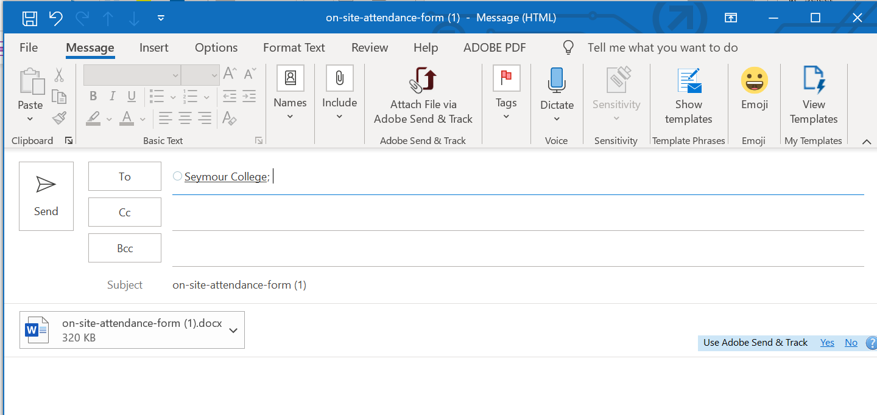
- This form can be completed using a mobile phone and word document editor and emailed back to
seymour.co@education.vic.gov.au : Attention Principal

