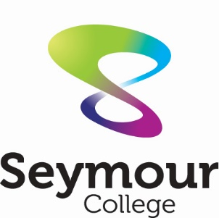
Seymour College

request for on-site attendance

valid from 15 to 17 February 2021
Student/s name:
Student/s date of birth:
Student/s year level: (F-10)
☐ I am requesting that my child/ren attend on-site learning because my child/ren is/are not able to be supervised at home and I am unable to work from home due to my work being listed as essential on the DHHS website.
I have made every effort to make other arrangements with family and emergency contacts due to the concern around the virility of the current coronavirus strain. I am also happy to further discuss this with school personnel. (For example, there are no other adults within the household complying with the stay-at-home orders, or close family that can provide care.)
If you qualified for on-site learning in 2020 it doesn’t mean you will automatically qualify for this ‘circuit breaker’ lockdown.
By submitting this form, I declare that my child/ren is/are well and I will collect my child/ren as soon as is practicable upon the request of the school if my child becomes unwell.
Email to: Seymour.co@education.vic.gov.au
by 5pm 14 February 2021

Dates required: | Day Date AM, PM or ALL DAY  Monday 15 Feb  Tuesday 16 Feb  Wednesday 17 Feb
Emergency contact details:
Parent/Guardian name: _________________________________________________

Signature: ____________________________________________________________

Date: _______________________________________________________________

Received and Processed by……………………….. on (date)……………………………………

