English Work Pack 2021
Year 8 – Term 4
Learning Intention  We are learning to engage with text | Success Criteria  I can:  - Read text  - Respond in writing  - Use reading comprehension skills  - Use appropriate language conventions

Instructions to Students:
Week 1
Activity
1 | Write a short narrative p.3
2 | Research author Louis Sachar p.3
3 | Respond to a summary of Holes about the setting p.3 - 4
4 | Read and respond to chapter 1 of Holes p.4 - 5
5 | Inference activity about the setting and the Warden from Holes p.5

Week 2
Activity
6 | Inference activity about Caveman, a character from Holes p.6
7 | Read an extract from Holes (p.45) and infer p.7
8 | Read chapter 25 and complete a character analysis of Sam the onion man p.7 - 9
9 | Read and respond to the final chapter of Holes p.9 - 11
10 | Write a personal refection p.12

Notes to Parents/Guardians:
You can support your child to complete their work at home by:
- Encouraging them to allocate time for specific subjects
- Reading the material and talking about the ideas with your child (where possible)
- Checking in with your child to ask how they are going
- Contacting teachers if more support or explanation is required

Submission of Work and Feedback:
Students can upload work to Compass where access is available. Photos of handwritten tasks may also be uploaded. Students can also mail hard copies of their work back to the school in the supplied envelope.
Students and parents can continue to communicate with teachers via Compass email. Any questions should be directed to the school email: seymour.co@education.vic.gov.au

Activity 1

Write a short narrative using as many of the following words as you can

Stanley Yelnats, arrested, innocent, great-great grandfather, curse, desolate, juvenile correction facility, digging, blister, friends, warden, venom, refuge, climbing, onions, destiny, treasure

Activity 2

Research the author Louis Sachar. Write down 8 things that you find out about him and his writing.

Activity 3

Read the summary of the novel ‘Holes’ by Louis Sachar and answer the following questions.

Holes Summary
Stanley Yelnats believes his family has been cursed. A story passed from generation to generation says that Elya, his great-great grandfather failed to fulfil a promise to an old Romani woman, who cursed him and his family. After being mistakenly convicted for stealing a pair of shoes, Stanley is sent to Camp Green Lake. The name is deceptive, the camp is a detention centre for boys in the middle of the Texan desert.
Stanley is thrown into tent D with a diverse mix of other juvenile delinquents, including a quiet boy named Zero. The “campers” are made to dig holes, under the watchful eye of Mr. Sir, the counsellor. Mr. Sir claims it is to build character but Stanley uncovers that the Warden is using the boys to help her search for something.
In a secondary plot, readers learn that Green Lake used to be a well-to-do area, rich and abundant, on the edge of a large lake. Kate, the school teacher falls in love with Sam, a local medicinal salesman. When the two are caught kissing, the town is in an uproar because Sam is black. Charles Walker, a member of the town’s richest family, wanted to court Kate. He leads the town in hunting down Sam, who is killed. Kate becomes a ruthless outlaw, “Kissing Kate Barlow”. As a bandit, she coincidentally robbed a man named Stanley Yelnats, the young protagonist’s great grandfather.
This first Stanley Yelnats also believed this is because of the Yelnats family curse. In Latvia, his father Elya fell in love, and wished to marry a young woman named Myra. Seeking the advice of Madame Zeroni, he was given a pig and told to carry it to the top of a mountain, allowing it to drink from the river. Once the pig grew, he could take it to Myra as a dowry. To repay Madame Zeroni, he was to carry her up the mountain to make her strong as well. When he goes to Myra, he is disgusted by her personality. Elya leaves for America, forgetting his end of the bargain.
These three stories collide when Zero and Stanley run away from the camp. After being in the desert for some time, they climb a mountain in search of water. Zero becomes weak and Stanley must carry him. When they reach the top they drink the water and Stanley sings a song taught to him by his family. Zero’s real name is Hector Zeroni, and he’s a descendant of Madame Zeroni. When Stanley carries him up the mountain and sings to him, the promise is fulfilled and the curse lifted. The boys then figure out that the Warden is a descendant of the Walker family and is in search of Kissing Kate’s buried Treasure, hence the endless digging of holes. They go back to a hole where Stanley found a lipstick container and find a box of treasure. The authorities are called in, the camp is shut down, and the boys live happily thereafter
Answer the following questions by looking them up or using the context of the writing to help give you clues to their meaning.
- What is a curse?
- What is deceptive?
- Who or what is a ‘juvenile delinquent’?
- Who or what is a ‘medicinal salesman’?
- The summary uses the phrase ‘court Kate’. What does this mean?
- What is a ‘ruthless outlaw’?
- What is a ‘secondary plot’?
- What is a ‘dowry’?

Activity 4
Read the first chapter of Louis Sachar’s novel ‘Holes’ and then complete the following activity. ‘Holes’ opens with a description of the setting of most of this story. Draw the setting. Be sure to include each thing on the following list, and as many details from the chapter as you can.
- Log cabin
- Hammock
- ‘Lake’ (is it really a lake?)
- Scorpions
- Rattlesnake
- Lizard
- Holes

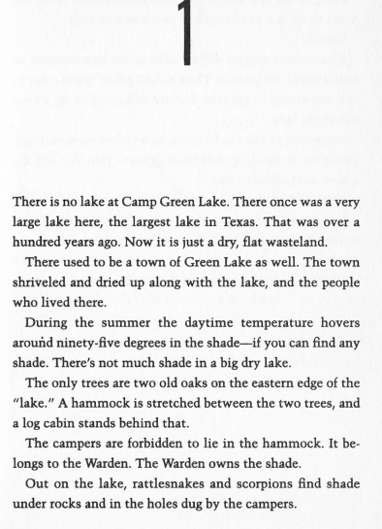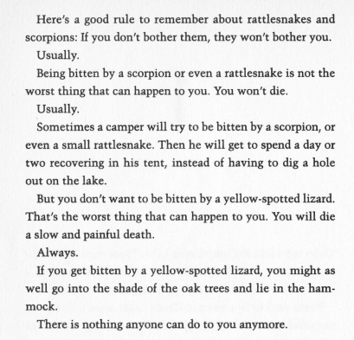
Activity 5
To infer something is to figure something out, or at least make a guess about something. A good inference is not a wild guess. It is based on evidence. If you knew only the name, you might infer that a place called ‘Camp Green Lake’ would have a lake, green plants and lots of fun things to do. However the first chapter gives you plenty of evidence to help you infer that Camp Green Lake is not a fun place.
Answer the following questions:
- What are three reasons you could infer that ‘Camp Green Lake’ is not fun for the campers?
- What is one reason you can infer that the Warden is not nice to the campers?

Activity 6
Read the following extract from ‘Holes’ (chapter 9, pg. 44) and answer the questions.
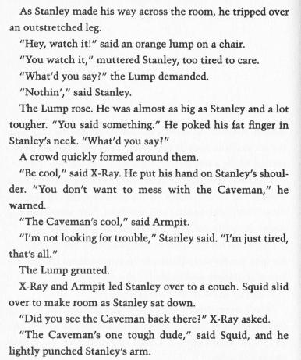
- We are introduced to a character named ‘Caveman’. Who does Stanley infer that the Caveman is?
- Why does he infer this?

Activity 7
Read the following extract from ‘Holes’ (p.45) and answer the questions.
- List the characters mentioned in this extract
- What can you infer about each one?
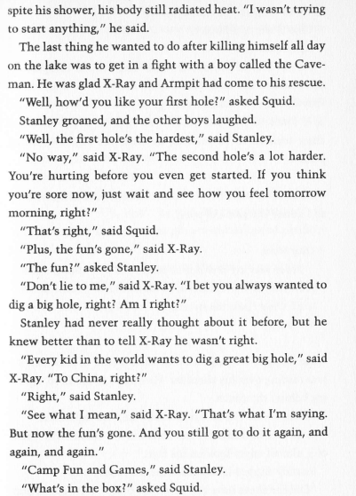
Activity 8
Read the following extract from chapter 25 and complete a character analysis of Sam (the onion man) by answering the following questions.

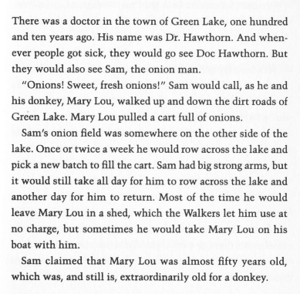CHAPTER 25
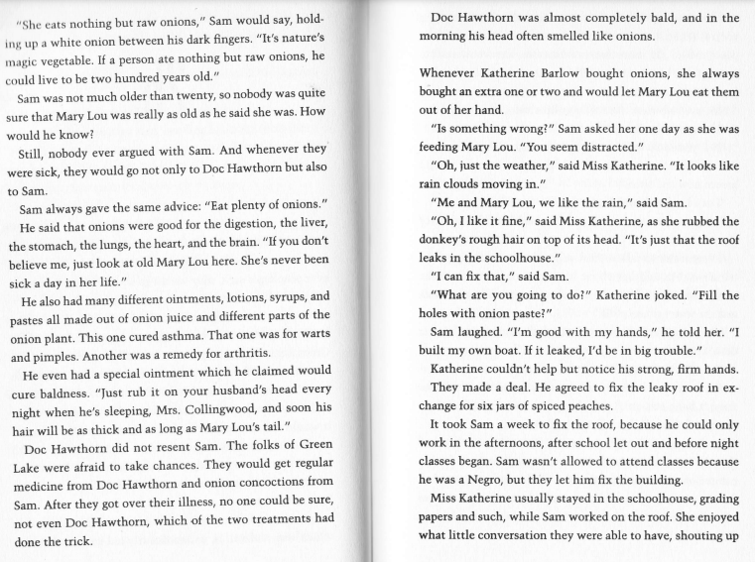
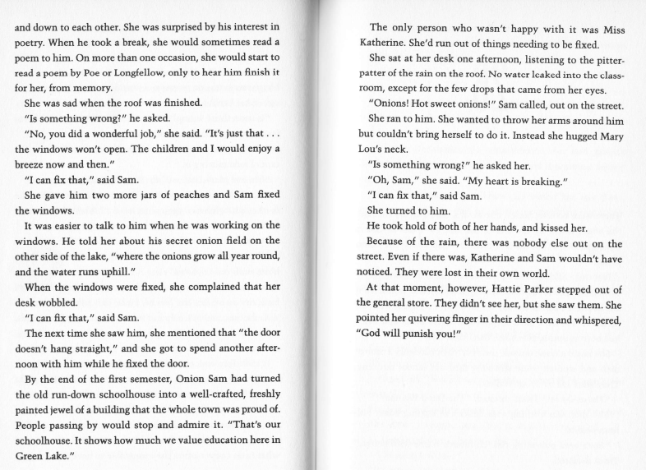
- Choose something that Sam Walker says from the chapter 25 extract above and respond to the following quetsions.
- What does he say?
- What does this tell you about him?
- What does Sam the onion man do that tells you what kind of person he is?
- Drawing
- Draw Sam in a scene from chapter 25. Include at least 3 details that help explain what Sam is like and what happens in this chapter.
- Reaction of Others
- Kate turns down Trout Walker’s offer for a boat ride; she does not like him because he is loud and stupid.
- How do people treat Sam?
- How does Kate treat Sam?

Activity 9
This is the final chapter of ‘Holes’. Read the following extract and answer the questions.
- Why might somebody infer that Stanley’s family had a curse on it, but it was over now?
- Who is the lady ‘sitting in the chair beside Hector’ (Zero) and why is she singing the same sort that Stanley learned from his parents?

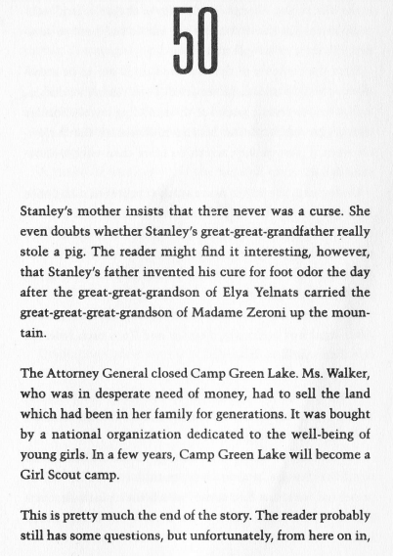
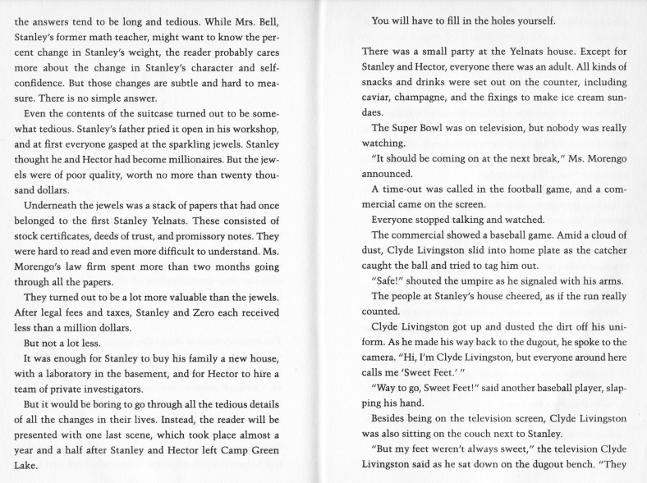
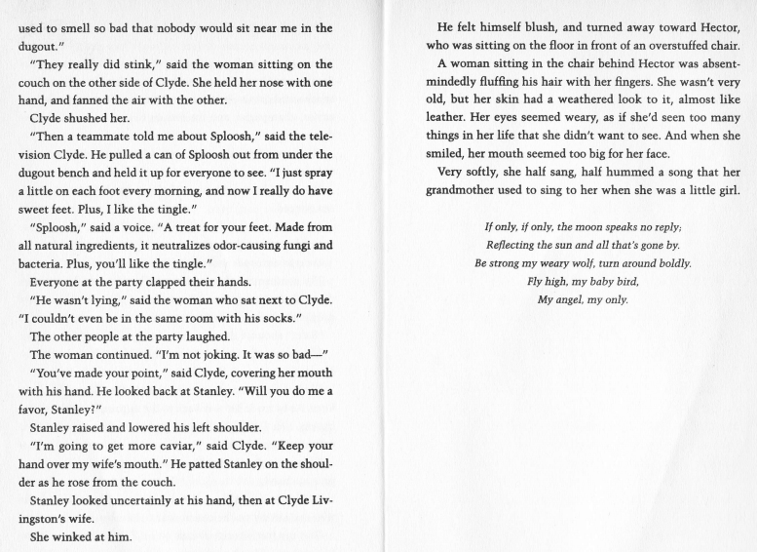

Activity 10
After reading the final chapter of ‘Holes’ write a personal reflection. Include in your paragraph comments about the setting, characters and plot. In addition, comment on any text-to-text, text to self or text to world connections you could make.

