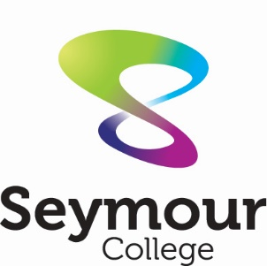
Seymour College
PO Box 266, SEYMOUR, VIC 3661
T (03) 5771 1300
seymour.co@education.vic.gov.au
www.seymourcollege.vic.edu.au

HIRE FACILITIES

SEYMOUR COLLEGE ARTS CENTRE

Our Arts Centre is a dynamic and flexible space that offers a range of facilities to suit and cater to a wide range of functions and events. Catering to both corporate and private function needs, The Arts Centre is the perfect choice for your special event with facilities perfectly suited to a range of uses.

Conventions, Presentations, Meetings, Theatre and Arts Performances, Product Launches, Displays, Expo's, Workshops and Education or Clubs and Group Gatherings, whatever your event, the Seymour College Arts Centre provides everything in one functional, modern and attractive space.

With facilities that cater to your individual needs, it is the perfect location for your event providing both a professional yet relaxed atmosphere in a well laid out and flexible environment.

The Arts Centre is perfect for both large and smaller group functions with state-of-the-art equipment suiting all of your event needs. The Arts Centre will make your event a success every time.
The Arts Centre is available for hire as an entire centre, auditorium and foyer or smaller spaces as required, and hire can be tailored to suit your individual requirements.

Auditorium:
The auditorium seats 267 people very comfortably in tiered seating and offers 3 spaces for wheelchair access. This large modern space is well set up to cater for many uses providing both a comfortable and professional feel with excellent viewing and sound from every seat in the house.

Both the stage and backstage areas have excellent facilities to cater to your events every need, with lighting, sound, change rooms, bathroom access and everything you would expect from a professional theatre space.
Perfect for theatre groups, concerts, conferences, presentations, product launches, education and many other corporate and private events.

Equipped with professional sound and lighting and controlled from the Auditorium sound booth, makes your event both professional, easy to manage and very comfortable.
Other equipment such as a projector, microphones and access ports support all of your technological requirements. The centre is temperature controlled and promises to give any function a winning edge.

A copy of the seating plan and stage dimensions is available on request.

Conference Room (Meeting Room):
Our conference room is an ideal space with seating to suit up to 40 people.
Access to a projector, speakers, and whiteboard caters to your needs. A well-lit space that offers round tables and chairs to suit your own configuration makes this the perfect meeting room and is available with the centre hire or as an individual space.

Foyer Breakout:
The large and spacious Foyer is suitable to many purposes.
Art exhibitions, expos, clubs, presentations, the Foyer is the perfect location to host your event. Ideal for displays with the flexibility to arrange this space to suit your individual needs and function.

Kitchennette:
Kitchenette facilities offer a space where you can prepare tea, coffee, drinks and small catering snacks. Crockery, utensils and large urns are available on site with some refrigeration available.

Catering:
Whilst the college does not offer catering we do recommend a number of local suppliers who are familiar with our facilities and can provide catering to your event needs and requests.
- JM & AM Service – Janine 0428 177 775 or meulenmeestersjanine@gmail.com (Schools Canteen Provider)
- No Café 96 – (03) 5799 0914
- Doug’s Bakery – (03) 5792 2376
- The Brewers Table – (03) 5792 2334 thebrewerstableseymour@gmail.com

FEES AND CHARGES
Effective 21/02/2024
Prices include GST

ARTS CENTRE

 | SCHOOL RATE | COMMUNITY RATE | COMMERCIAL
1 Room  (Minimum 3 hours) | $39 Per hour | $61 per hour | $83 per hour
2 Rooms  (Minimum 3 hours) | $50 per hour | $81 per hour | $110 per hour
3 Rooms  (Minimum 3 hours) | $78 per hour | $122 per hour | $166 per hour
Whole Facility | $110 per hour | $166 per hour | $220 per hour
STUDIO | $39 per hour | $44 per hour | $66 per hour
- Hirers must provide own suitable qualified technical staff, if required.

SPORTS STADIUMS

Hall/Stadium | COMMUNITY RATE
Junior Games Hall | $44.00 per hour
Senior Sports Stadium | $44.00 per hour

Where we are located.
Corner of Loco Street and Anglesey Street Seymour Victoria.

Located in the regional township of Seymour and within the Seymour College grounds, the Arts Centre is perfectly situated in an easy to promote location with ample street parking available on Loco Street and Anglesey Street and around the centre and well-lit front exposure.

With everything on offer that is usually only available in larger cities, the Art Centre is the perfect place to host your event.

Seymour College also offers our Junior Games Hall and Senior Sports Stadium for hire and our staff are happy to provide further information and discuss hire options to cater to your needs.

Viewing and enquiries are most welcome by contacting the College on 03 5771 1305

- All hirers must provide copy of current public liability.
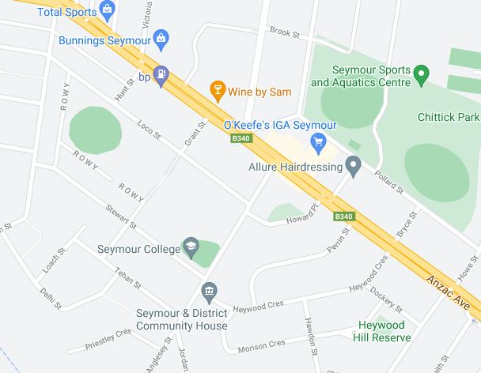
Application to Hire School Facilities

Name of Applicant: …………………………………………………………………………………………………….

Organisation: …………………………………………………………………………………………………………….

Address: ……………………………………………………………………………………………………………………

Phone: ………………………………………. Mobile: …………………………………………………………………

Facility Required | Date/s | Start Time | Finish Time
Arts Centre Conference Room
Arts Centre Foyer / Kitchenette
Arts Centre Auditorium only
Arts Centre Whole Facility
Junior Games Hall
Senior Stadium

Please note that it is our preference that no food or drink be consumed in the Auditorium. Smoke machines are prohibited. Please let us know if you have any questions.

Any other Requirements: (e.g. tea/coffee, seating arrangements, projector, microphone, internet access)

…………………………………………………………………………………………………………………………………

Details of Activity:

…………………………………………………………………………………………………………………………………

Estimated number of people attending: ………………………………………………………….

A copy of your Certificate of Currency for Public Liability Insurance must be provided prior to hire. Please attach a copy of Certificate.

Signed: ……………………………………………………………………………………………….

Date:……………………………………………..

